Right of Way Worksheet
- What is the intersection type?
- If both arrive at the same time, which color car has the right of way and why?
- If white arrives first, which color car has right of way and why?

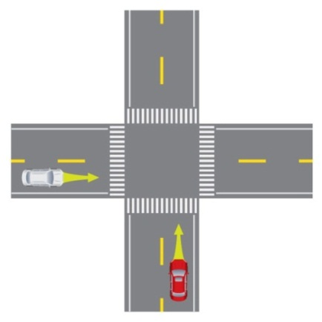

- What is this intersection type?
- If all 3 cars arrived at the intersection at the same time, in what order do the cars have the right of way and why?
- What is the order if the white car arrives first?

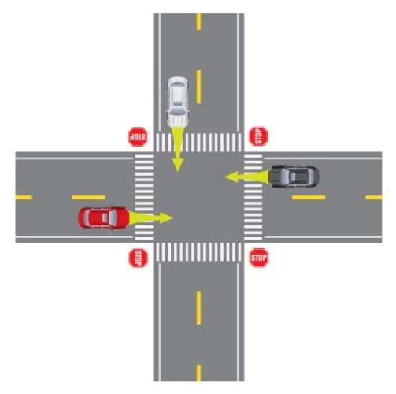

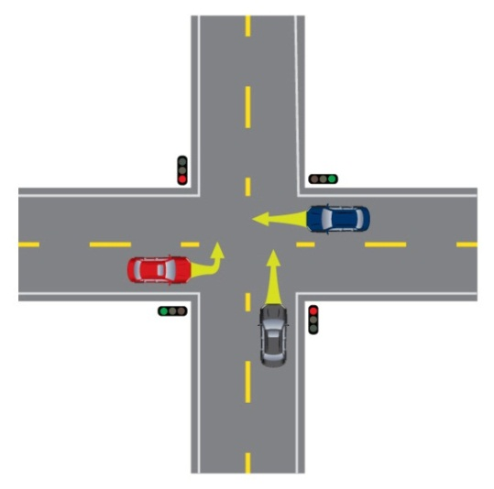
- The cars all arrived at the intersection at the same time. In what order do the cars have right-of-way and why?
- How might drivers communicate? ID 2 ways.

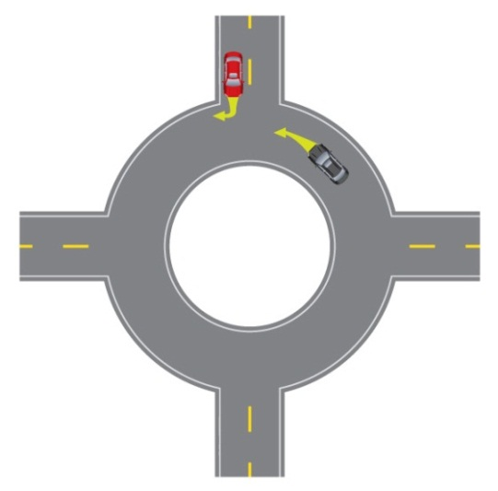
9. What is this intersection type?
10. Who has the right of way?
11. How and when would the cars communicate?

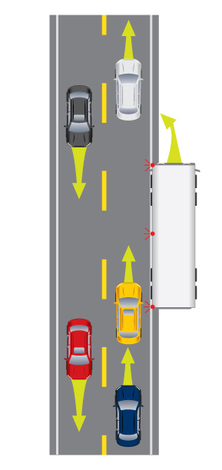
- Which vehicle has the right-of-way?
- Which vehicles need to yield?
- Which vehicle do you think has an unsafe space margin?

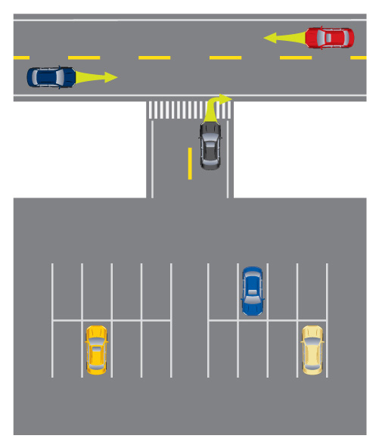
15. To what two categories of road users does the car entering the street need to yield right of way to?

