Name____________________________________
- 2-Way roadway divided by a median
- 2-Way road with passing not permitted from either side
- 2-Way road with a reversible lane
- 2-Way road with a shared left turn lane
- 2-Way road with passing allowed only for traffic moving in direction of the arrow
- 2-Way road with passing not permitted for traffic moving in direction of the arrow
- 2-Way road with passing permitted in either direction
- 2-Way 3-Lane road with middle lane reserved for left turns only in direction of the arrow

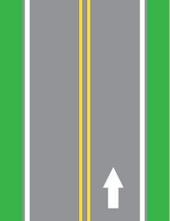 _______  2  1. | 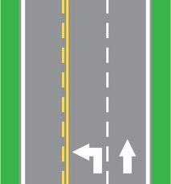 ________
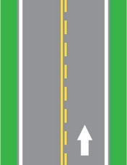 ________  4.  3. | 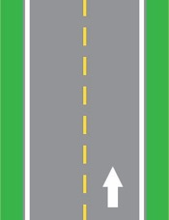 ________
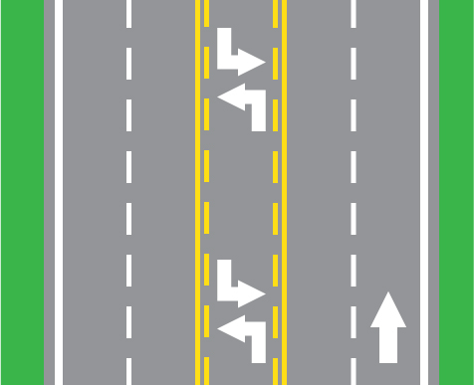 ________  5.  6. | 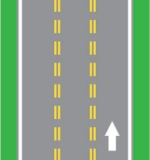 ________
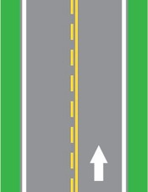 ________  7.  8. |  

